* Fixation, memory cue, another fixation, verbal judgement, then a small part of the object they had to remember, and tell them if it was in the memory cue
* Will cue larger and smaller
* X axis: difference between the large and small object within a scene
* Y axis: change in verbal estimate between two cueing conditions (delta)
* Scatter plot of points that look like the identity line
* 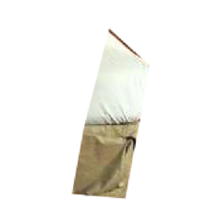Graphical user interface, text, application

  Description automatically generatedA picture containing fabric

  Description automatically generatedA picture containing indoor, floor, wall, bed

  Description automatically generatedA picture containing bed, furniture, pillow, seat

  Description automatically generated\

500 ms

Response

Probe

time

300 ms

+

Sample Object

1s

+

500 ms

500 ms

+

+

500 ms